**RIPHAH INTERNATIONAL UNIVERSITY, ISLAMABAD**



**Lab 4**

**Bachelors of Computer science – 5th semester**

**Subject:** Artificial Intelligence Lab

**Submitted to:** Ma’am Ayesha

**Submitted by:** Munaza Malik

**Sap Id:** 44956

**Date:** 25th February, 2025

**Task 1:**

Write a program that calculates the sum of all even numbers from 1 to 20 using a For loop.

**Code:**

total_sum = 0  
for i in range(1, 21):  
 if i % 2 == 0:  
 total_sum += i  
print("Sum of even numbers from 1 to 20 is:", total_sum)

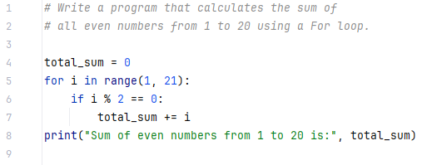

**Output:**



**Task 2:**

Find the smallest number in the list.

**Code:**

numbers = [50, 40, -1, 50, 6]  
smallest = numbers[0]  
  
for number in numbers:  
 if number < smallest:  
 smallest = number  
  
print("The smallest number in the list is:", smallest)

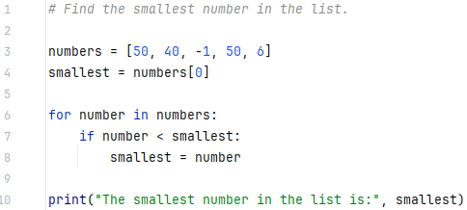

**Output:**



**Task 3:**

Extend the first list with elements from the second list.

**Code:**

list1 = [1, 2, 3]  
list2 = [4, 5, 6]  
  
list1.extend(list2)  
print("Extended list:", list1)

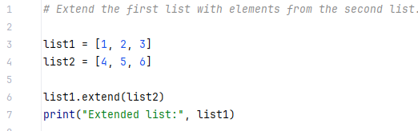

**Output:**



**Task 4:**

Write a Python program that takes a non-negative integer as input and calculates its factorial using a while loop.

**Code:**

num = int(input("Enter a non-negative integer: "))  
  
if num < 0:  
 print("You entered a negative number")  
else:  
 factorial = 1  
 i = 1  
 while i <= num:  
 factorial *= i  
 i += 1  
 print("Factorial of", num, "is:", factorial)

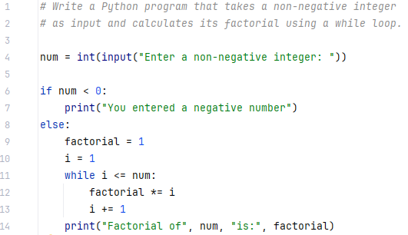

**Output:**

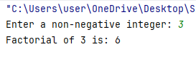

**Task 5:**

Check which letter is vowel or which is not. In else condition print “Consonant”?

**Code:**

letter = input("Enter a letter: ")  
  
if letter in ['a', 'e', 'i', 'o', 'u' , 'A', 'E', 'I', 'O', 'U']:  
 print("Vowel")  
else:  
 print("Consonant")

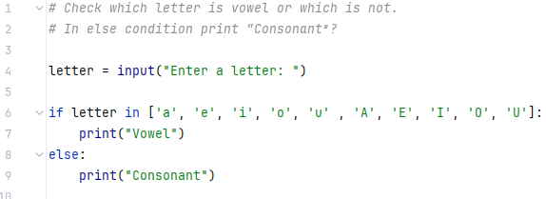

**Output:**

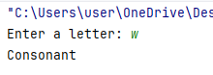

**Or**

